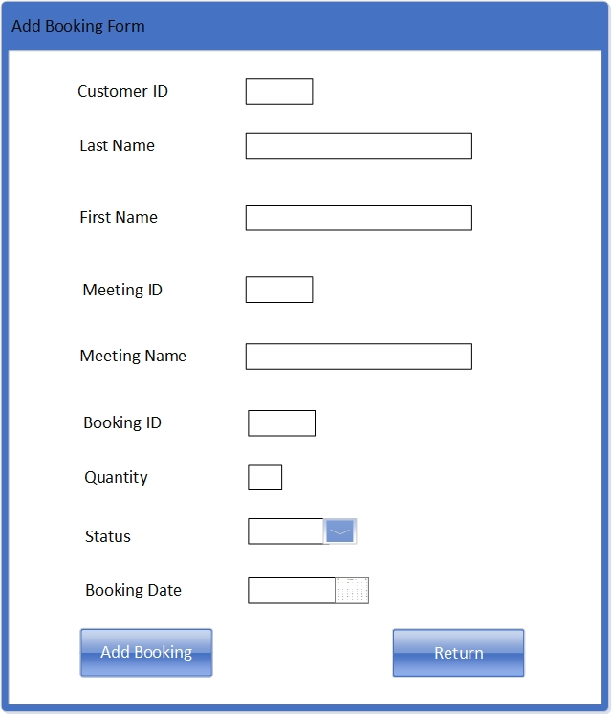

Button that saves the Booking and displays the message “Booking added Successfully”

Button that returns User to Main Menu

Booking Date, Calendar Box selection. Max 10 Characters.

Status Drop Down Box list. Max 7 Characters.

Quantity Text Box, Max of 1 Character.

Auto Number, Max 5 Characters. Read-Only Text Box

Meeting Name is a Text Box. Max 25 Characters.

Auto Number, Max 5 Characters, Read-Only text box

Auto Number, Max 5 Characters. Read-Only text box

Last Name and First Name are Text Box. Max 25 Characters.

Button that saves the Horse and displays a message “Horse Added Successfully”

Button that returns User to Main Menu

Last Name and First Name are Text Box. Max 25 Characters.

Auto Number, Max 5 Characters, Read-Only text box

Date Of Birth Calendar Box selection. Max 10 Characters.

Gender Drop Down Box list. Max 7 Characters.

Horse Name Text Box. Max 25 Characters.

Auto Number, Max 5 Characters. Read-Only text box



Button that saves the Race Entry and displays a message “Race Entry added to Race Successfully”.

Horse Drop Down Box list. Max 25 Characters

Jockey Drop Down Box list. Max 25 Characters.

Button returns user to Main Menu

Status Drop Down Box list. Max 12 Characters.

Race and Meeting Name Max 25 Characters. Text Box

Auto Number, 5 Max Characters. Read-Only text box

Race Entries List Box.

Race Drop Down Box list. Max 25 Characters.

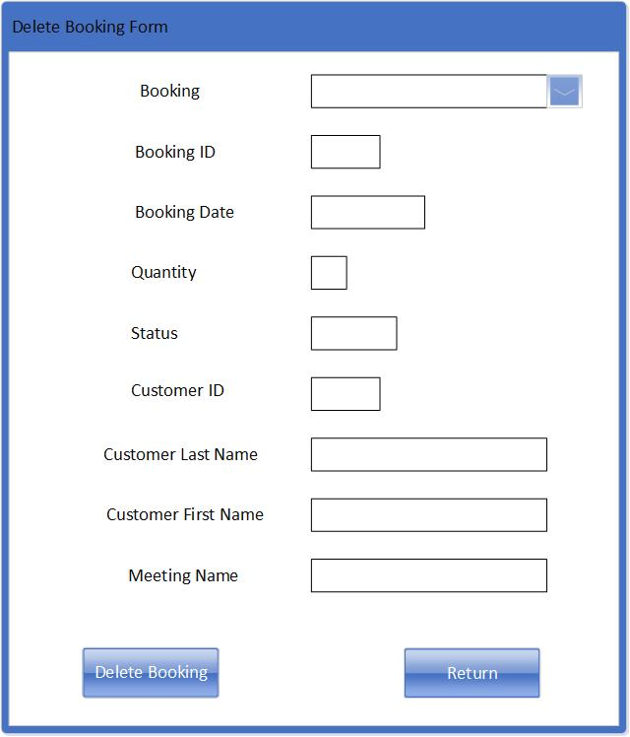

Button that deletes Booking Record and displays a message “Booking Deleted Successfully”.

Button returns user to Main Menu

Customer Last Name, First Name and Meeting Name Max 25 Characters. Read-Only Text Box

Auto Number, 5 Max Characters. Read-Only text box

Status Box. Max 7 Characters. Read-Only text box

Quantity Box. Max 1 Character. Read-Only text box

Booking Date. Max 10 Characters. Read-Only text box

Auto Number, 5 Max Characters. Read-Only text box

Booking Drop Down Box list. Max 25 Characters.

Horse Name Max 25 Characters. Read-Only Text Box

Date of Birth Max 10 Characters. Read-Only Text Box

Owner Last Name and First Name Max 25 Characters. Read-Only Text Box

Auto Number, 5 Max Characters. Read-Only text box

Horse Drop Down Box list. Max 25 Characters.

Button that deletes Horse Record and associated race details and displays message “Horse Deleted Successfully”

Button that returns user to Main Menu

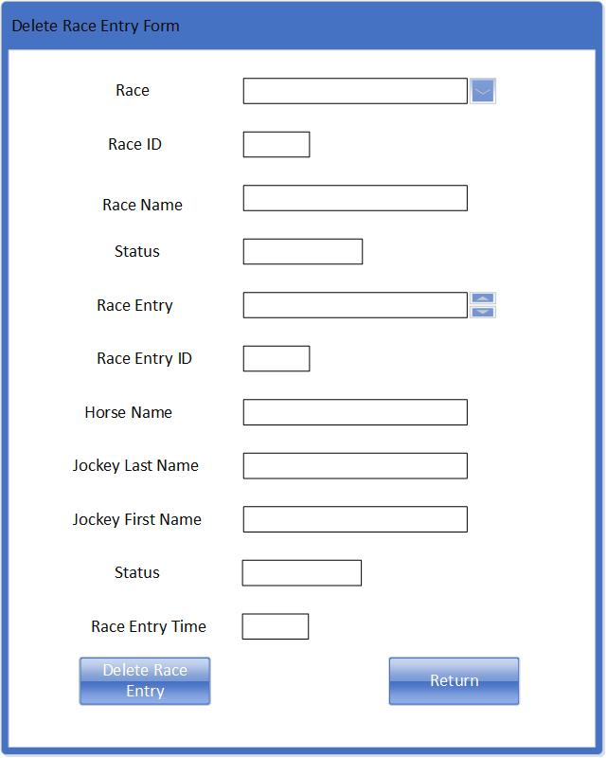

Race Entry Time box. Max 5 Characters. Read-Only Text Box

Button that deletes Race Entry record and displays message “Race entry Deleted Successfully”

Button that returns user to Main Menu

Status Box Max 12 Characters. Read-Only Text Box

Status Box Max 12 Characters. Read-Only Text Box

Horse Name, Jockey First and Last Name 25 Max Characters. Read-Only Text Box

Auto Number, 5 Max Characters. Read-Only Text Box

Race Entry Select list button type. Max 25 Characters.

Race Name Max 25 Characters. Read-Only Text Box

Auto Number, 5 Max Characters. Read-Only text box

Race Drop Down Box list. Max 25 Characters.

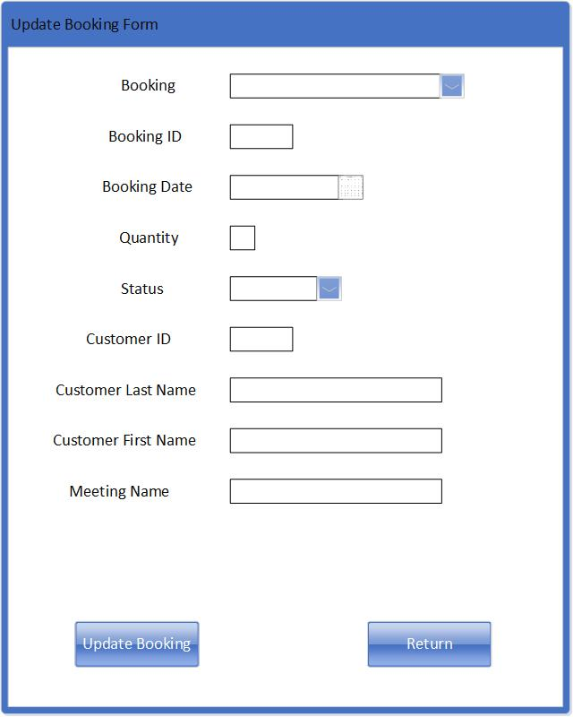

Button that updates Booking Record and displays message “Booking Updated Successfully”

Button returns user to Main Menu

Customer First Name, Last Name and Meeting Name Max 25 Characters.

Auto Number, Max 5 Characters. Read-Only Text Box

Status Box. Max 7 Characters. Drop down selection

Quantity Box. Max 1 Character

Booking Date, Calendar selection. Max 10 characters

Auto Number, Max 5 Characters long. Read-Only text box

Booking Drop Down Box list. Max 25 Characters.

Button that updates Horse Record and displays message “Horse Updated Successfully”

Button that returns user to Main Menu

Owner Last Name and First Name Max 25 Characters

Date Of Birth, Calendar selection. Max 10 Characters

Gender box. Max 7 Characters. Drop down selection

Horse Name Box. Max 25 Characters

Auto Number. Max 5 Characters long. Read-Only Text Box

Horse Drop Down Box list. Max 25 Characters.